Niger

## Respect for rule of law (ROL) data

The data set shows the data on the respect of the rule of law for the country.

## # A tibble: 19 x 5  
## country iso3c date ruleOfLaw ruleOfLawCategory4   
## <chr> <chr> <dbl> <dbl> <chr>   
## 1 Niger NER 1996 -0.655 ROL moderately disrespected  
## 2 Niger NER 1998 -0.559 ROL moderately disrespected  
## 3 Niger NER 2000 -0.723 ROL moderately disrespected  
## 4 Niger NER 2002 -0.640 ROL moderately disrespected  
## 5 Niger NER 2003 -0.519 ROL moderately disrespected  
## 6 Niger NER 2004 -0.641 ROL moderately disrespected  
## 7 Niger NER 2005 -0.707 ROL moderately disrespected  
## 8 Niger NER 2006 -0.591 ROL moderately disrespected  
## 9 Niger NER 2007 -0.599 ROL moderately disrespected  
## 10 Niger NER 2008 -0.668 ROL moderately disrespected  
## 11 Niger NER 2009 -0.479 ROL moderately disrespected  
## 12 Niger NER 2010 -0.482 ROL moderately disrespected  
## 13 Niger NER 2011 -0.390 ROL moderately disrespected  
## 14 Niger NER 2012 -0.648 ROL moderately disrespected  
## 15 Niger NER 2013 -0.660 ROL moderately disrespected  
## 16 Niger NER 2014 -0.646 ROL moderately disrespected  
## 17 Niger NER 2015 -0.579 ROL moderately disrespected  
## 18 Niger NER 2016 -0.669 ROL moderately disrespected  
## 19 Niger NER 2017 -0.676 ROL moderately disrespected

## Respect for rule of law (ROL) trend

The plot shows the trend of the respect for the rule of law for the country.

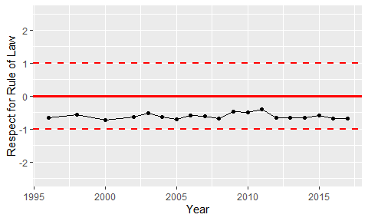

Trend of the Respect for the Rule of Law